German Saturday School Teaching Award
Nomination
Name of school | Hackney Wick
Name of head teacher and contact email address | Ulrike Hensel-Burg  hackney@samstagsschule.co.uk
Name of nominated teacher and contact email address | Frauke Ehmke  detour.consulting@gmail.com
Head teacher’s statement  Up to 100 words – a brief statement about the nominee and why s/he was chosen | Frauke has been a teacher at our school since its launch in September 2011. According to our system, she taught the same group for 5 years and has now moved on to a younger group of children. We suggest Frauke for her amazing way of combining art with teaching German in her lessons, making Saturday School very playful for the children. Frauke incorporates aspects of the children’s world in her projects, thus ensuring a strong engagement. By discussing all aspects of the projects with the children, Frauke inspires children to extend their German vocabulary and express their thoughts and feelings in German.
Nominee’s statement  Up to 500 words – a description of your project in any format including pictures, or even a short film (max. 1 min.).  You could include the following information;  - What was the aim of the project?  - Which age groups were involved?  - How did the project further the pupil’s German language learning?  - What was special about your pedagogical approach?  - What is the evidence for the success of this project?  - How did the project have an effect beyond the Saturday School?  - What was the feedback from pupils and parents?  - Why did you chose this project? | See separate attachment

Art and Language
My name is Frauke Ehmke and I am in my sixth year of teaching at the German Saturday School Hackney Wick. I have a BA in Fine Arts and over 20 years experience in the arts sector and have previously worked with children in museums like the Hayward Gallery.
Since becoming a parent myself in 2006, I have developed a particular interest in children’s education, which corresponds with my philosophy of art, and where both can coexist. I have established many innovative and playful strategies to build children's confidence and to enhance their language skills. The children often inspire my ideas. The following two examples demonstrate how I combine visual work with a story or topic.
"Rules"
In my current group of 6-year-olds we have looked at rules: exploring rules together, we started talking about where we find rules, what they mean and why rules can be useful. We talked about traffic rules and house rules. The children drew a bear while listening to the story "Bear Tale" by Janosch, in which a boy has enough of his parents’ rules, turns into a bear and behaves according to his own rules. The children then felt surprised and empowered when asked to develop their own rules. Making rules became a democratic process in which everyone was involved.
Each child developed a game on paper and then we positioned the games next to one another. Equipped with a dice and a figure the children had to adapt to different rules. The rules changed every time they moved onto a new game square. The children made up the rules and the inventor of each game explained her/his rule to the rest. We jumped over rivers and fires, went through tornados and reflected on rules and new words.
This is a playful attempt to make children think about rules and also a demonstration of how children can engage through art in the complexity of rules. The visual part of the task allows the students to reflect and supports the process of expressing their ideas in German through interaction.

I find working creatively in this way, allowing children space and time to express and develop their ideas themselves, supports the process of new learning in a highly personalised way. I am delighted when I see children taking their ideas forward in unexpected directions. Through the medium of art children can gain a sense of belonging, which helps to strengthen their confidence and improves fine motor skills which all play a crucial role in cognitive development.
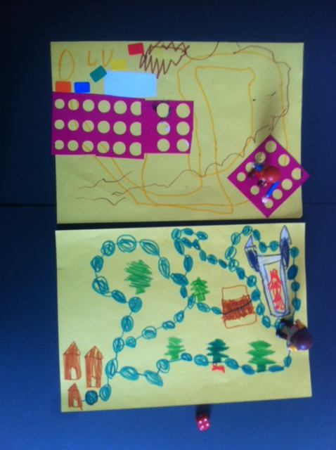
Frauke's groups created their own games as part of the rules project
Workshop on "friendship":
During our German Summer School I developed a workshop about our topic "Friendship". With the 4-6year-olds, I read the book by Leo Lionni, "The Little Blue The Little Yellow", a very abstract book on friendship and colour. Little Blue was little Yellow's best friend. One day when Little Blue disobeyed his mother and went to play with Little Yellow, they hugged each other so tightly that each became green. Each group explored how colour is mixed by acting this story out on paper and we talked about new colours and friendship games.
The 6-9-year-olds each got a sheet of paper and had to draw something they associated with friendship. After one minute, everyone passed their paper clockwise to the next person for another minute, and so on. By the end everyone had drawn on each sheet of paper and each sheet was a collaboration done by all children. The result was beautiful and showed that everyone had respected the first mark on the paper and continued the drawing accordingly.
The kids were excited throughout this process and very surprised by the "finished product". We discussed that everyone has a voice and feelings and that friends have to respect one another. The children talked about their best friends and what they can do to make friends and that playing with three friends can be difficult at times as one person can feel left out. The children discovered that imaginative friends can be useful too.
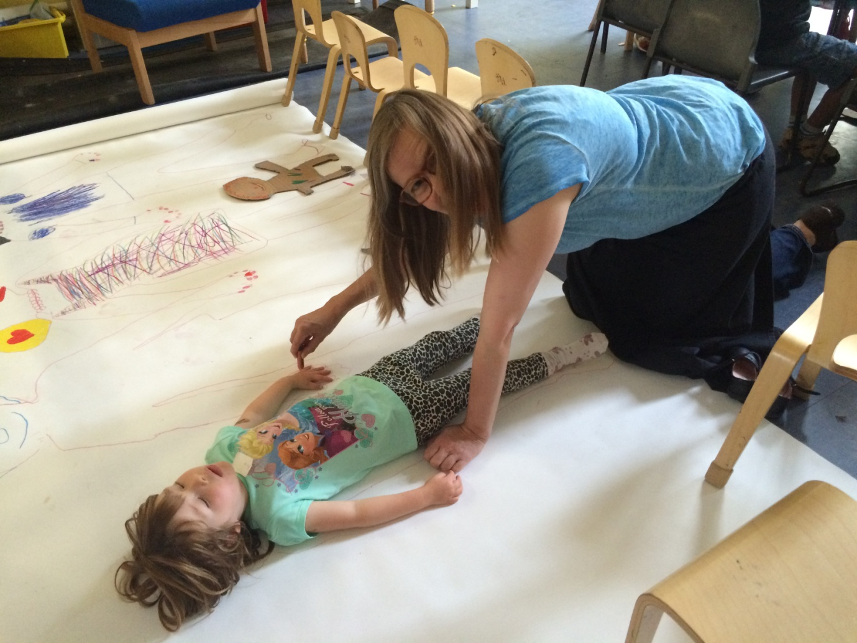
Frauke's groups incorporating art work during the friendship project

