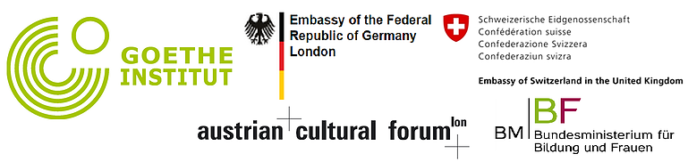

Teacher training event February 2015
This year’s teacher training event took place on 14 February 2015 in the rooms of the Goethe Institute in London, South Kensington. It was jointly sponsored by the German Embassy, the Swiss Embassy, the Austrian Cultural Forum and Austrian Ministry of Education.
We had two lectures in the morning. Dr Ana Souza, Visiting Fellow at the Institute of Education (London) with many years of experience with the Brazilian supplementary schools, initially presented a brief history of supplementary language schools in Britain before focusing on bilingual education. Which respective value do German and English have with our children? How does their bilingualism influence their perception of identity? These and similar questions were discussed with the audience. We all realised how important the Saturday school is for our children.
Linda Owen, language consultant from Sidebyside-Learning, dealt with a completely different topic: The use of new media in language teaching. Although the German Saturday schools usually do not have access to modern technology during lessons (e.g. interactive whiteboards, tablet PCs), digital technology (internet software, apps) can nonetheless play a more important role in lesson preparations, during teaching and in the support of children. Linda focused on free programmes and apps and presented a wealth of sources and ideas.
After a delicious buffet lunch, the afternoon was dedicated to four different workshops. Everyone had to join in. Katrin MacSweeney presented the textbooks that her school in Manchester is using throughout the year groups. In the discussions that followed it became clear that many Saturday schools do not use textbooks at all – the approaches are quite variable from school to school.
Parallel to this session, Christine Müller (SS Islington), reported, how she communicates with the parents of her pupils and how she involves them in the lessons. Here too similar and quite different practice in different schools became apparent.
After a coffee break, Jana Gugelot (SS Hackney Wick) introduced a number of language promoting games that she regularly uses in class. This list was substantially extended by contributions from the audience. In the parallel workshop, Bettina Wulf and Silvia Hohmann (SS Richmond) presented many practical lesson ideas about the topic ‘grammar’, supplemented by ideas from the audience.
In the late afternoon everybody was exhausted from a long day of stimulating discussions. 50 teachers from 15 different schools had travelled to London – even Alemann-Fun from Edinburgh were represented. In addition to concrete teaching ideas, the informal exchange between teachers was particularly appreciated. The background noise during breaks was significant and discussions were very lively indeed - the general feedback was very positive.

